Bahria University,

Karachi Campus



LAB EXPERIMENT NO.

5

LIST OF TASKS

|  |  |
| --- | --- |
| TASK NO | OBJECTIVE |
| **1** | Write a sketch to blink the 2 LEDs interfaced with Arduino at a different rate simultaneously. (i.e. “delay” function limits the designer to perform multitasking from the controller, so this sketch is implement without utilizing this function). |
| 2 | Write a sketch to implement the one-way traffic light controller using FSM concepts. The sensor will work to sense the traffic on the road whose output will be the stimulus for the state transition. |

Submitted On:

1/11/2022

(Date: DD/MM/YY)

**Task No. 1:** Write a sketch to blink the 2 LEDs interfaced with Arduino at a different rate simultaneously. (i.e. “delay” function limits the designer to perform multitasking from the controller, so this sketch is implement without utilizing this function).

**Output:**

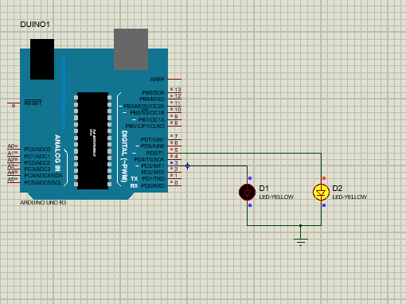

**Task No. 2:** Write a sketch to implement the one-way traffic light controller using FSM concepts. The sensor will work to sense the traffic on the road whose output will be the stimulus for the state transition.

**Output:**

